**Experiment No. – 9**

**Aim:** 1. Design a Feedback Amplifier with the close-loop Output resistance of 1k

Given: A=200V/V, Rin= ∞, Rout=10K

2. Repeat Part 1 with feedback Network as follows:

**Apparatus Required:** LTSpice Software

**Theory:**

A feedback amplifier generally consists of two parts. They are the amplifier and the feedback circuit. The feedback circuit usually consists of resistors.

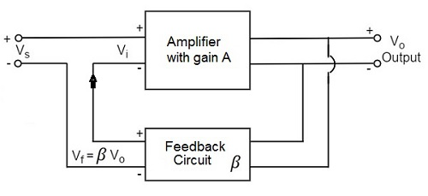

The process of injecting a fraction of output energy of some device back to the input is known as Feedback.

**Circuit Schematic 1:**

With Rin= ∞

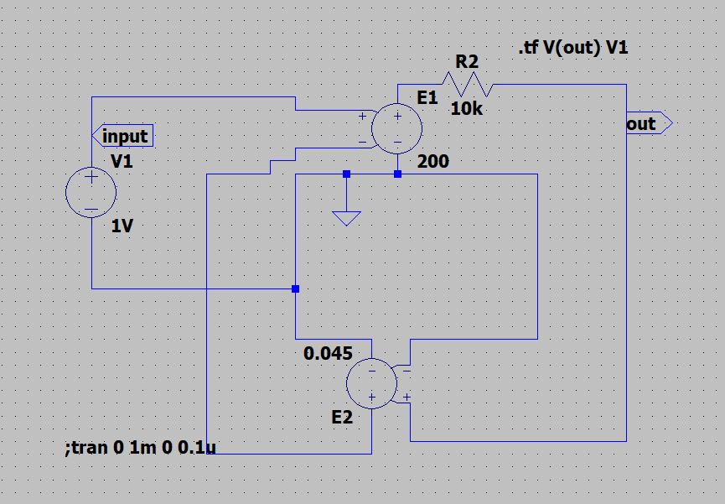

**Output:**

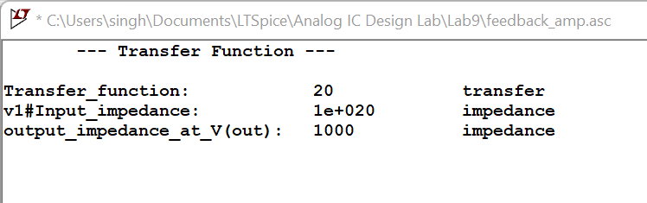

**Circuit Schematic 2:**

With input Resistance Rin= ∞

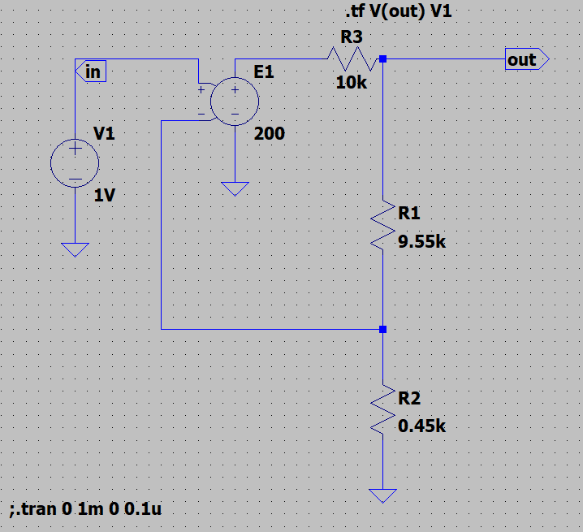

**Output:**

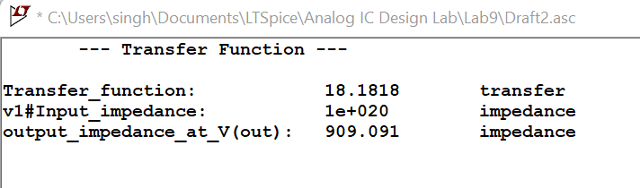

With Input Resistance Rin= 100K

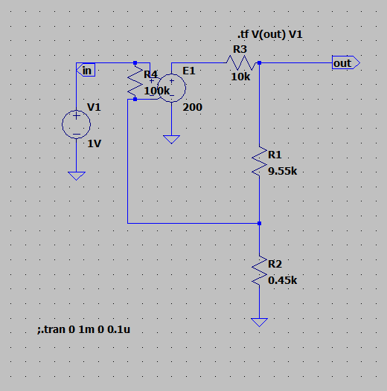

**Output:**

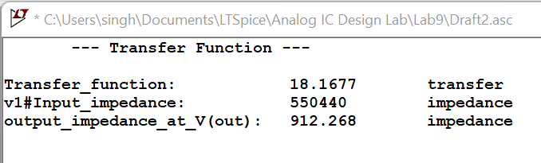

**Result:**

The circuit is designed for a Feedback Amplifier with the close-loop and the output is verified to be correct.